Article ID: 3064
Article Name The light on my Fridge Freezer are flashing
Topic Location: Cooling/Fridge Freezer/Broken Damaged
Meta-data: combi
Related Articles:
Related Questions:
PNC
DIY
Safety
Link
Email
X Book Engineer
Multimedia
Brand
Article Content:
Flashing light:
Internal light bulb is loose or defect. Fasten or replace the bulb as described in user instructions.
Flashing light bulb or led lights can also indicate that the ambient temperature that is too warm or too cold. Check the temperature classification as indicated on the rating plate.
The proper operation can only be guaranteed for a SN-class appliance in an ambient temperature of +10°C to +32°C.
- Class N = 16-32°C
- Class SN = 10-32°C
- Class ST = 18-38°C
- Class SN/T = 10-38°C
Climate classification indication on rating plate:
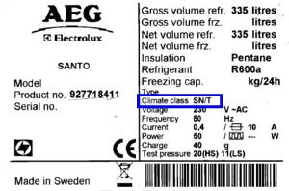

Accessories and spare parts you can find in our web shop.
(webshop)
If none of the above advises solved the problem a service engineer can resolve it for you.
(Book engineer design)

